In Factory pattern, we create object without exposing the creation logic to the client and refer to newly created object using a common interface.

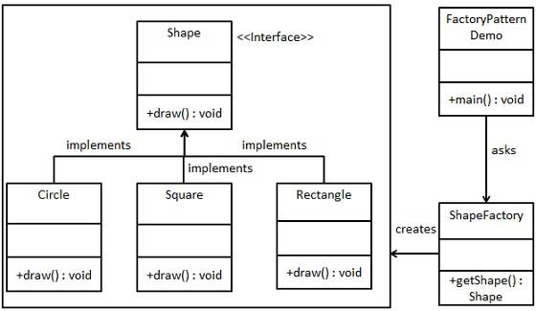

package com.sample.designpattern;

interface Shape {
public void draw();
}

class Circle implements Shape {
public void draw() {
System.out.println("Inside Circle Draw");
}
}

class Square implements Shape {
public void draw() {
System.out.println("Inside Square Draw");
}
}

class ShapeFactory {
public static Shape getShape(Class<? extends Shape> c) {

if (c.getName().equals(Circle.class.getName())) {
return new Circle();
}
return new Square();
}
}

public class FactoryMethodClient {
public static void main(String[] args) {
Shape s = ShapeFactory.getShape(Circle.class);
s.draw();

Shape s1 = ShapeFactory.getShape(Square.class);
s1.draw();

}

}

